**App Launch Flow Diagram**

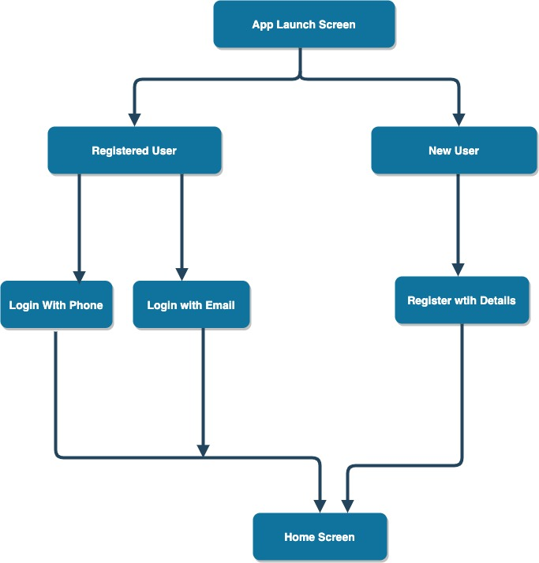

**Home Screen Flow Diagram**

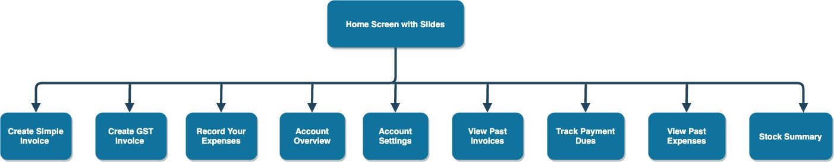

**Create Invoice Flow Diagram**

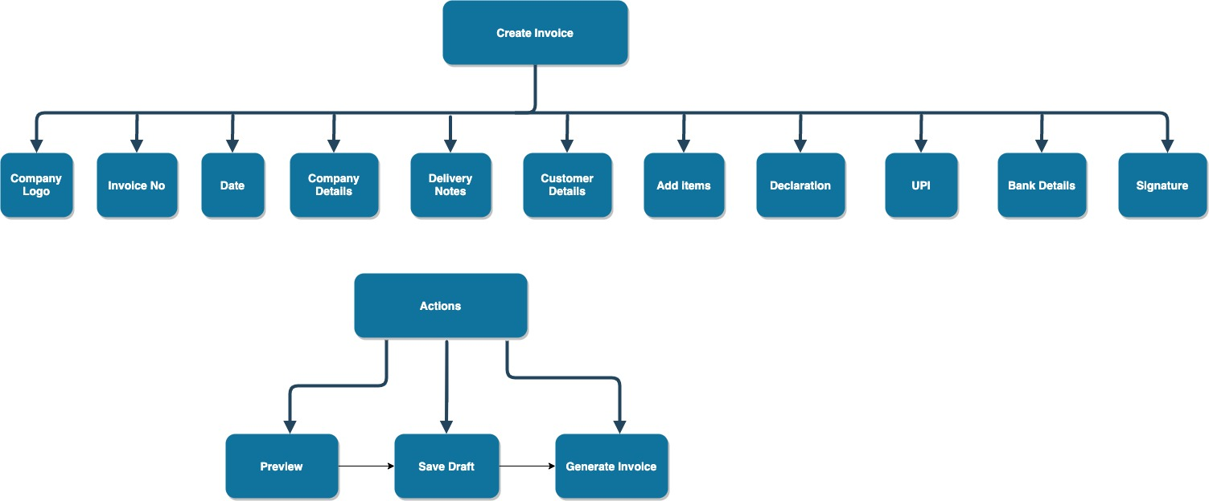

**Record Expenses Flow Diagram**

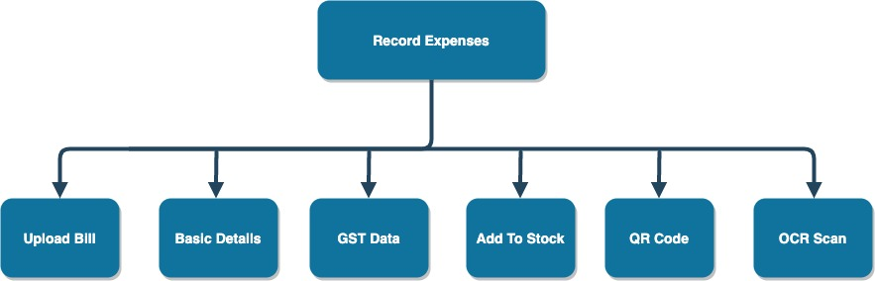

**Account Overview Flow Diagram**

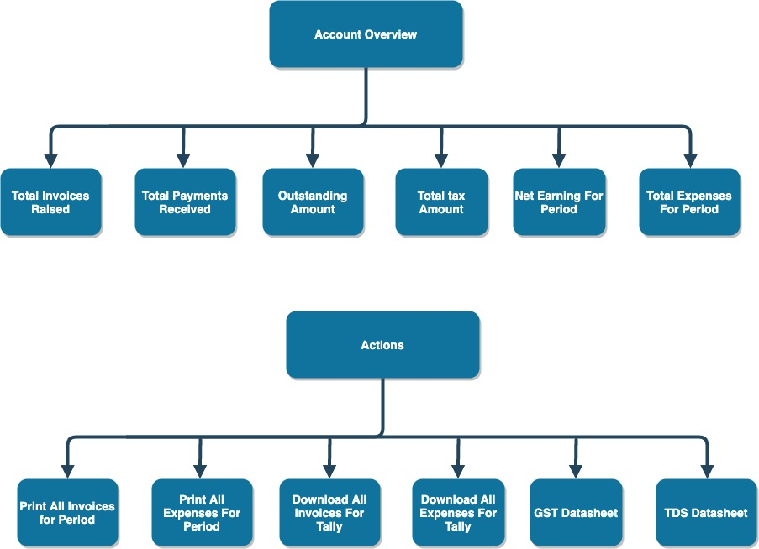

**Account Settings Flow Diagram**

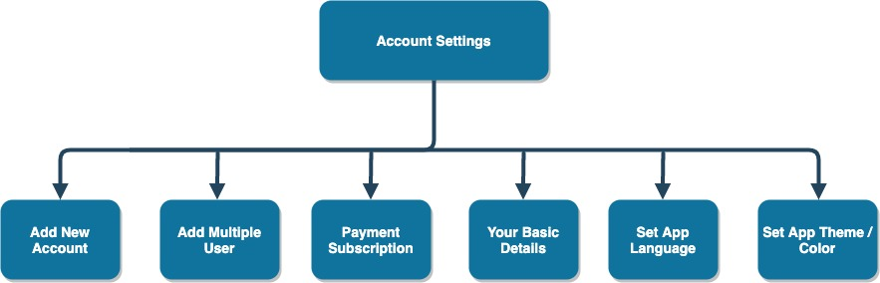

**Past Invoices**

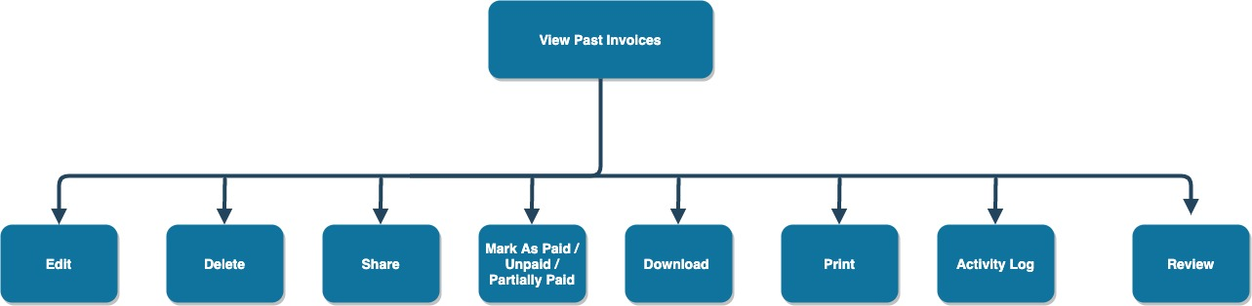

**Track Payments dues**

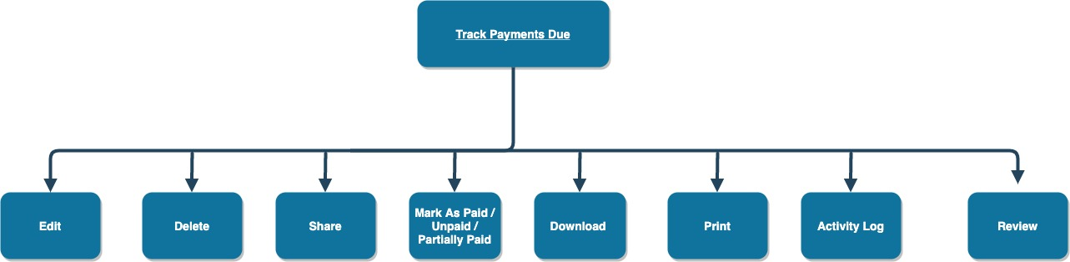

**View Past Expenses**

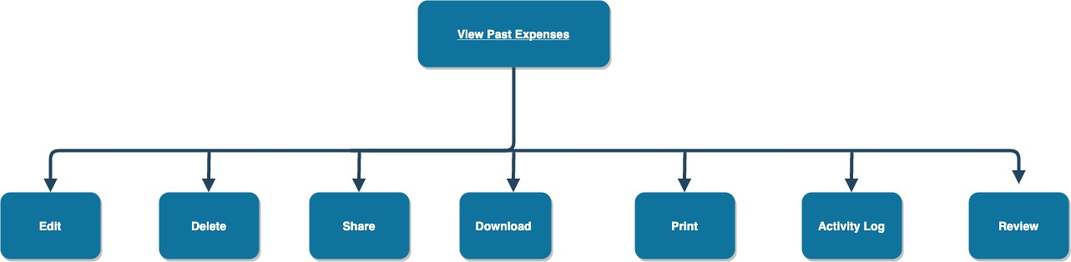

**Stock Summary**

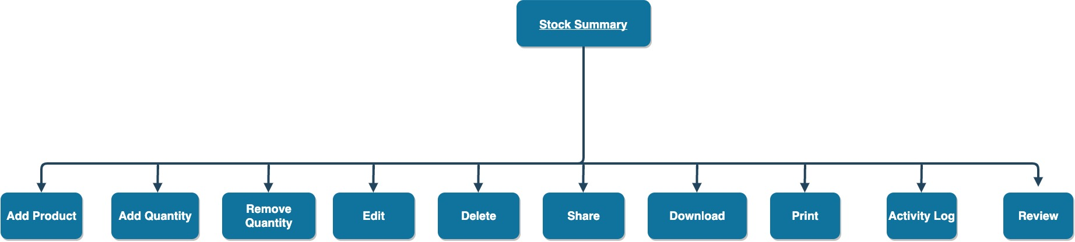

**Subscription / Plans Flow Diagram**

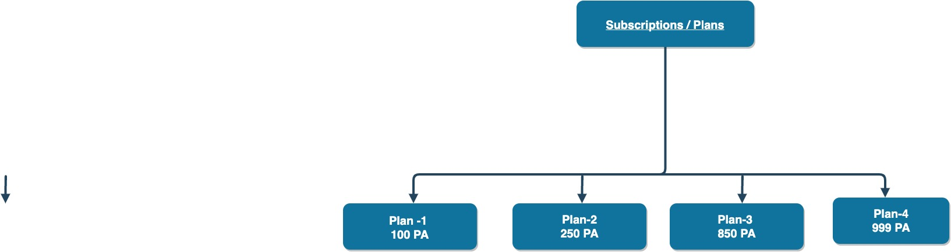

**Reminder Flow Diagram**